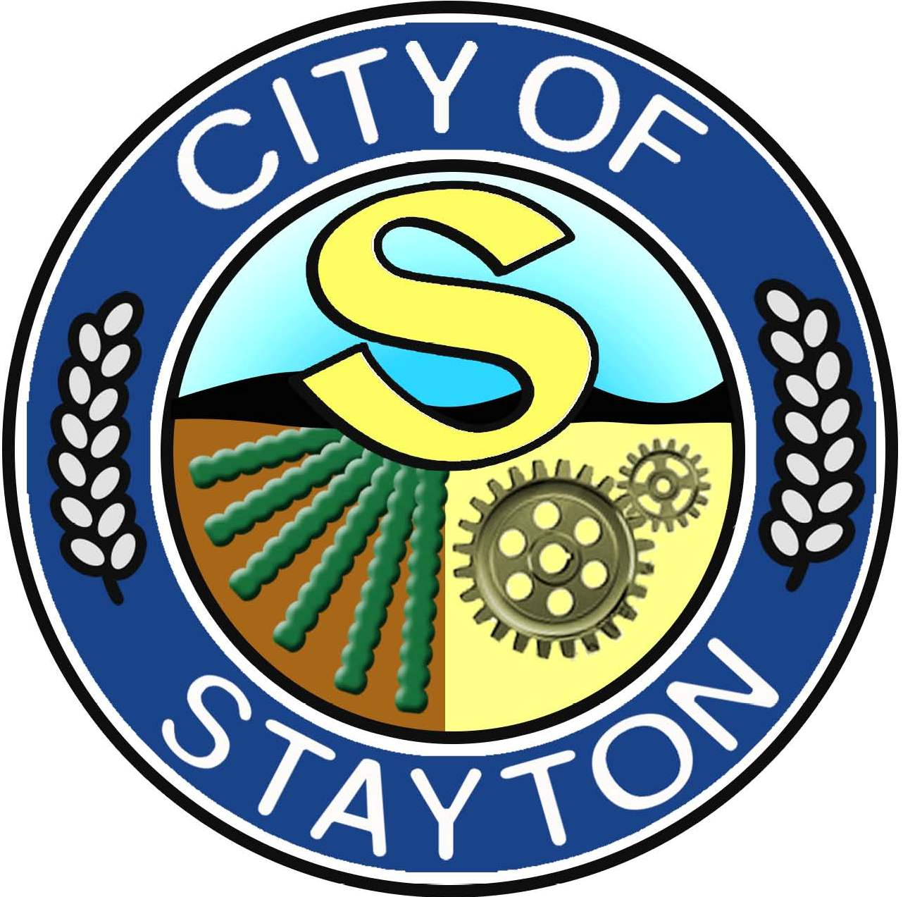

CITY OF STAYTON PUBLIC ARTS COMMISSION

Thursday, June 20th, 2024
Public Works Conference Room

ROLL CALL

Present: Mark Kronquist
Nick Raba
Amy Watts (1/2 Meeting)

Absent: N/A

Staff: Jennifer Siciliano, Community & Economic Development Director
Christian Smithrud, Community Engagement Coordinator
Aaron Frichtl, President of RDS
Windy Cudd, Office Specialist (Minutes)

Guest(s): None

CALL TO ORDER: Kronquist called the meeting to order at 6:05pm.

PRESENTATIONS / COMMENTS FROM THE PUBLIC: None

PUBLIC ARTS COMMISSION FLYER: Discussed the flyer

REVIEW AND APPROVAL OF MINUTES: Postponed to Next Meeting
FUTURE AGENDA-

ADJOURN Meeting was adjourned at 7:39pm.
NEXT MEETING DATE- July 18th, 2024 @ 6:00pm, at Public Works Conference Room

